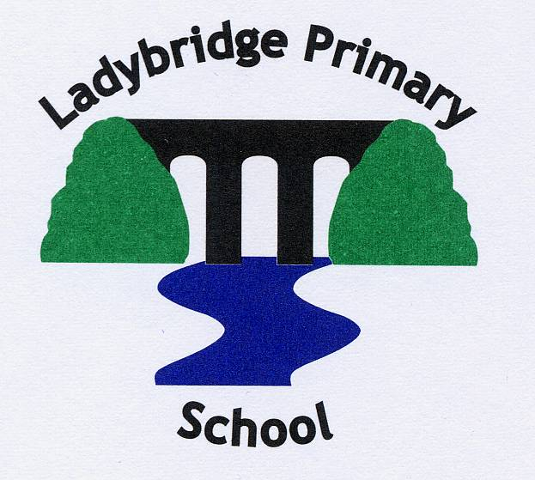
Leadership Roles 2021-22
Child Protection/Safeguarding – Emma Hill, Sarah Ratcliffe, Patrick Fenwick, Amy Davies: Governor Tom Morrison
Health and Safety –Emma Hill, Jackie Cooper, Katherine Dumenil: Governor Ash Tucker
Inclusion/SENCO – Patrick Fenwick: Governor Ash Tucker
Curriculum and Assessment Lead – Amy Davies
Art and Design – Sarah Woodworth
Computing – Katie Kendry
Design and Technology – Sarah Woodworth
English – Hayley Nugent
Geography – Emily Burke
History – Kim Goodwin
Languages – Amy Davies
Mathematics – Patrick Fenwick, Amy Davies
Music – Emma Hill
PE – Patrick Fenwick
PSHE/RSE – Helen Parker
RE – Kim Goodwin
Science – Helen Parker
EYFS/KS1 Leader – Kim Goodwin
KS2 Leaders – Patrick Fenwick/Amy Davies
Wellbeing – Helen Parker: Governor Amy Davies
Young Carers – Sarah Ratcliffe: Governor Amy Davies

